For the first portion of the assignment, we had to do what every language demands the ‘Hello World’ program. In this program I learned to use Trap 15, with Task 14 (only learned what the tasks meant after doing HW1). I also learned how to use the CR and LF, which is different from all other languages I know (usually is \n) as you needed to do a EDU $0D and $0A in order to make it work.

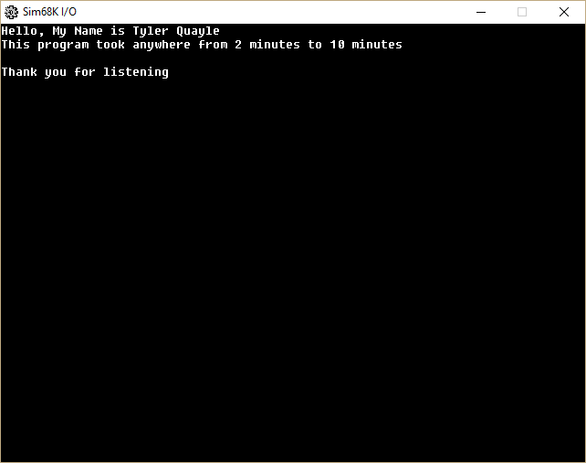

For the Second portion of Lab1 we had to do a Branching program, which we than modified do be from 20-25. This program taught me quite a bit about assembly programming, as with C++, Python, C#, Java the IF statement is essential, if the requirements are not met, ignore what’s inside the curly braces. With assembly you have to control the curly braces with branching. I found out first had what happens if you don’t jump properly, you end up just reading out all statements one after another, which isn’t great for a program which should reject or display certain inputs.

